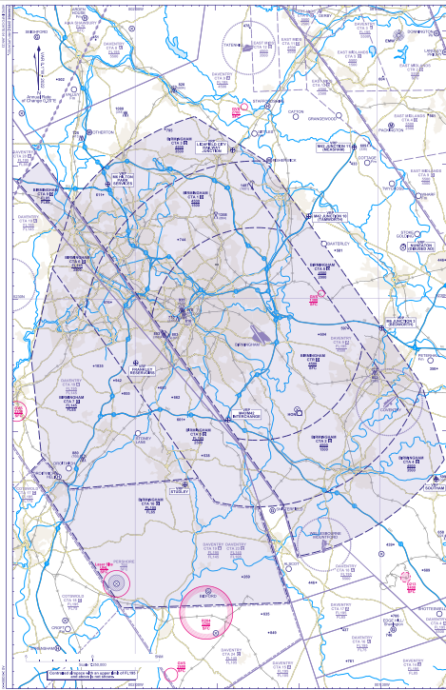
Total infringements to date (as of 31.12.2024): 43 (including Daventry CTA-9 AI’s)
1
3
2
1
2
1
4
4
23

Date of Occurrence | Zone Infringed | Infringement Level
January
13.01.2024 | CTA-2 | 2000ft
18.01.2024 | CTA-2 | 1600ft
19.01.2024 | CTA-2 | 1700ft
February
Nil infringements recorded
March
Nil infringements recorded
April
12.04.2024 | CTA-2 | 2000ft
May
04.05.2024 | CTA-1 | 2300ft
18.05.2024 | CTA-2 | 2700ft
18.05.2024 | CTA-8 | 2700ft
19.05.2024 | CTA-5 | 2700ft
24.05.2024 | CTA-9 | 5000ft
June
05.06.2024 | CTA-10 | FL100
06.06.2024 | Birmingham CTR | 2500ft
07.06.2024 | CTA-5 | 3000ft
07.06.2024 | CTA-1 | 1900ft
09.06.2024 | CTA-2 | 1600ft
15.06.2024 | CTA-2 | 1600ft
17.06.2024 | CTA-1 | 1600ft
18.06.2024 | Daventry CTA-9 | 4600ft
27.06.2025 | CTA-2 | 1600ft
July
06.07.2024 | Birmingham CTR | 900ft
10.07.2024 | CTA-2 | 2500ft
12.07.2024 | CTA-2 | 2000ft
26.07.2024 | Daventry CTA-9 | 5100ft
26.07.2024 | CTA-2 | 1700ft
26.07.2024 | CTA-2 | 1600ft
28.07.2024 | CTA-2 | 1700ft
30.07.2024 | CTA-2 | 1500ft
30.07.2024 | Birmingham CTR | 700ft
August
08.08.2024 | CTA-4 | 3900ft
09.08.2024 | CTA-8 | 2300ft
09.08.2024 | CTA-2 | 1600ft
12.08.2024 | CTA-7 | FL100
18.08.2024 | CTA-2 | 1500ft
28.08.2024 | CTA-2 | 1500ft
29.08.2024 | CTA-2 | 1600ft
31.08.2024 | CTA-2 | 1700ft
September
12.09.2024 | CTA-2 | 1600ft
13.09.2024 | CTA-2 | 1600ft
14.09.2024 | CTA-2 | 2800ft
October
17.10.2024 | CTA-4 | 3600ft
19.10.2024 | Birmingham CTR | 1100ft
November
13.11.2024 | CTA-4 | 4000ft
15.11.2024 | CTA-1 | 1900ft
December
06.12.2024 | CTA-2 | 2600ft

