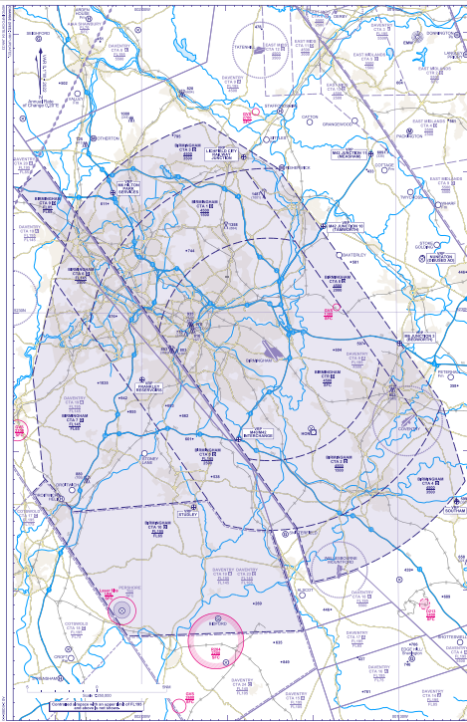
Total infringements to date (as of 25.03.2025): 9
1
1
2
5

Date of Occurrence | Zone Infringed | Infringement Level
January
10.01.2025 | CTA-4 | 4000ft
13.01.2025 | CTA-3 | 1900ft
February
13.02.2025 | CTA-2 | 1800ft
13.02.2025 | CTA-2 | 2600ft
March
04.03.2025 | CTA-4 + CTA-5 | 3500ft
06.03.2025 | CTA-2 | 1800ft
08.03.2025 | CTA-2 | 1600ft
15.03.2025 | CTA-2 | 1600ft
16.03.2025 | CTA-1 | 1700ft

